Screening Completed: ___________________________

(yyyy/mm/dd) (hhhh)

Screening to be completed each time patient presents to C5, as well as prior to scheduled C-sections/inductions by phone.

Date of Scheduled Procedure: ___________________________

(yyyy/mm/dd) (hhhh)

Section 1: Community Prevalence
 | Yes | No | Date if applicable
Returned from travel outside of province or Resided in high prevalence area#?
Area or Postal Code___________

#Prevalence Tool. High prevalence is defined as “HIGH” or > 0.75

Section 2: Patient Risk Factors: In the last 14 days, has the patient

 | Yes | No
Returned from travel outside of Canada or in contact with a sick traveller?
Tested COVID-19 Positive or currently awaiting COVID-19 test results due to having symptoms?
Been in close contact with someone suspected or confirmed COVID-19?
Lived or worked in a setting that is part of a COVID-19 outbreak?

Patients who answer “Yes” to Section 2 should have flag “CONTACT and DROPLET Precautions -COVID QUARANTINE” entered in PCS

Section 3: Patient Symptoms:

Does the patient have any NEW or UNEXPLAINED symptoms listed below? (onset last 7 days)

 | Yes | No | Obstetric-specific symptoms | Yes | No
Cough |  |  | Fever (temperature 37.8 Celsius or more)¹
Sore throat or difficulty swallowing
Shortness of breath
Runny nose/nasal congestion
Nausea/Diarrhea
Changes in sense of smell/taste
¹If patient experiences only fever upon presentation, assign category “Yellow” and follow OBSTETRIC FEVER FLOWCHART

Section 4: Patient Risk Category

- Patient answered NO to ALL questions, Risk category GREEN (see Table 2. PPE requirements). No testing required.
- Patient answered YES to section 1 and NO to Section 2 and 3, testing recommended
And circle YELLOW (see Table 2. PPE requirements)
- Patient answered YES to 2 or more sections MRP should be notified and testing recommended (see Table 1.)

Patient Risk Category

GREEN | YELLOW | RED

______________________________________________________________________________________________
Screener Name Designation Signature Date Time

Utilize OBSTETRIC FEVER FLOWCHART, Table 1, and Table 2 to determine testing and PPE recommendations

OBSTETRIC FEVER FLOWCHART

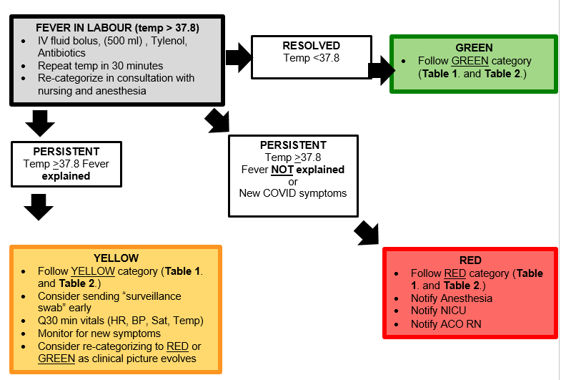

Table 1. Testing Guidance and Results Interpretation

“Yes” to any of Section 1 | “Yes” to any of Section 2  COVID QUARANTINE | “Yes” to any of Section 3 | Testing Recommendation | Result from COVID Test (within 72 hours of procedure) | Updated Risk Category
 |  |  | Not Required | Not Applicable | GREEN
✓ |  |  | Recommended  Surveillance swab | Negative | GREEN
 |  |  |  | Unknown | YELLOW
 |  |  |  | Positive | RED
 | ✓ |  | Recommended  Surveillance swab | Positive/Unknown | RED
 |  |  |  | Negative | YELLOW
 |  | ✓ | Recommended  Diagnostic swab | Positive/Unknown | RED
 |  |  |  | Negative | YELLOW
✓ | ✓ |  | Recommended  Surveillance swab | Positive/Unknown | RED
 |  |  |  | Negative | YELLOW
✓ |  | ✓ | Recommended  Diagnostic swab | Positive/Unknown | RED
 |  |  |  | Negative | GREEN
✓ | ✓ | ✓ | Recommended  Diagnostic swab | Positive/Unknown | RED
 |  |  |  | Negative | YELLOW
 | ✓ | ✓ | Recommended  Diagnostic swab | Positive/Unknown | RED
 |  |  |  | Negative | YELLOW

Updated Patient Risk Category:
GREEN | YELLOW | RED

Table 2. PPE Requirements and Additional Precautions Based on Updated Risk Category
Event/Procedure | GREEN | YELLOW | RED
Assessment and Disposition | All Staff – Assessment Area  - Procedure mask  - Eye protection  - +/- Gown/Gloves  Patient  - Procedure mask | All Staff – Assessment Area  - Procedure mask  - Eye protection  - Gown/Gloves  Patient  - Procedure mask | All Staff – TR 11  - Procedure mask  - Eye protection  - Gown/Gloves  Patient  - Procedure mask
Vaginal Delivery and Epidural | All Staff – L&D Room  - Procedure mask  - Eye protection  - Gown (waterproof for delivering MD)/Gloves  Patient  - Procedure mask | All Staff – L&D Room  - Procedure mask  - Eye protection  - Gown (waterproof for delivering MD)/Gloves  Patient  - Procedure mask | All Staff – LDR 5  - Procedure mask  - Eye protection  - Gown (waterproof for delivering MD)/Gloves  Patient  - Procedure mask
Caesarean Delivery Connell 5  Spinal or GA | All Staff – OR  - Procedure mask  - Eye protection  - Head cover  - Gown/Gloves (sterile for surgical team)  Patient  - Procedure mask  Support Person (OR)  - Procedure mask  - OR attire | All Staff – OR  - Procedure mask OR N95*  - Eye protection  - Head cover +/- disposable cover  - Gown/Gloves (sterile for surgical team)  Patient  - Procedure mask  Support Person  - OR/Kidd 5 isolation (at discretion) | All Staff – OR 2  - Fit-tested N95*  - Eye protection (shield)  - Head cover and disposable cover  - Gown/Gloves (sterile for surgical team)  - Neck drape (airway team)  Patient  - Procedure mask  Support Person  - Kidd 5 isolation
Caesarean Delivery  Main OR  Spinal or GA | All Staff – OR  - Procedure mask  - Eye protection  - Head cover  - Gown/Gloves (sterile for surgical team)  Patient  - Procedure mask  Support Person  - Waiting room | All Staff – OR  - Procedure mask OR N95*  - Eye protection  - Head cover +/- disposable cover  - Gown/Gloves (sterile for surgical team)  Patient  - Procedure mask  Support Person  - Waiting room/Kidd 5 isolation (at discretion) | All Staff – OR D  - Fit-tested N95*  - Eye protection (shield)  - Head cover and disposable cover  - Gown/Gloves (sterile for surgical team)  - Neck drape (airway team)  Patient  - Procedure mask  Support Person  - Kidd 5 isolation
Environmental Services  IF intubation required | Routine Practices | Wait 45 minutes from extubation for air clearance  No precautions = regular clean  OR  Contact/Droplet Precautions for COVID-19 Quarantine = Deep Clean | - Procedure mask  - Eye protection  - Gown/Gloves  Deep Clean
Patient flags (PCS) | None | None  OR  CONTACT and DROPLET PRECAUTIONS-COVID QUARANTINE | CONTACT and DROPLET PRECAUTIONS-COVID-19  OR  CONTACT and DROPLET PRECAUTIONS-QUERY COVID-19
* As per COVID-19 Directive #5 under section 77.7 of Health Protection and Promotion Act each individual is to perform a point-of-care risk assessment (PCRA) to determine the level of PPE that is appropriate for each patient encounter and cannot be unreasonably denied access to appropriate PPE.

